REPORT on

KIA MOTORS

Subject: Seminar
Subject code: MIS-156
Submitted in partial fulfillments of the requirements for the reward of degree of Master in Business Administration (MBA FYIC)
[2017-2022]
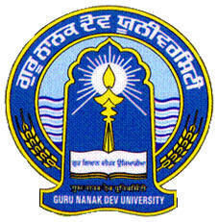

Submitted to: - Submitted by: -
[Prof. Amanjot Singh] [PARTH PATEL]
[Prof. Bisman Kaur] [Roll NO.:-2017MGA1061]
UNIVERSITY BUSINESS SCHOOL
GURU NANAK DEV UNIVERSITY, AMRITSAR

KIA MOTORS CORPORATION

Kia Motors Corporation was founded in 1944 and is Korea’s oldest manufacturer of motor vehicles. From humble origins making bicycles and motorcycles, Kia now produces more than three million vehicles a year from 14 manufacturing and assembly operations in five countries. These vehicles are sold and serviced through a network of distributors and dealers covering around 180 countries worldwide. Globally, Kia has over 50,000 employees and annual revenues of nearly US$44 billion.

Global research, development and production

In the company’s homeland of South Korea, Kia operates three major vehicle assembly plants at Hwasung, Sohari and Gwangju, as well as a world-class research and development centre employing around 12,000 vehicle development engineers and staff at Namyang. Kia’s Eco-Technology Research Institute near Seoul is working on next-generation hydrogen fuel-cell powertrains. Kia spends around 6% of its annual revenues on R&D, and also operates research centres in the USA, Japan and Germany.
Kia operates a global network of manufacturing bases outside Korea, with advanced production facilities in the USA, Slovakia, China and Mexico. Kia has a global production capacity of 3.5 million cars per year. Vehicles are built on flexible assembly lines which can manufacture several different models simultaneously to adapt to global changes in buying trends.
In addition, Kia has a long history of building locally in a number of markets to meet the specific needs of local customers, with assembly operation using ‘car kits’ (supplied from Korea) in Ecuador, Iran, Malaysia, Russia, Uruguay and Vietnam.

Design-led transformation

Design forms a key part of Kia’s long-term plan to become one of the world’s leading automotive brands. The last decade has seen a design revolution at Kia, a shift which has fundamentally altered the way in which consumers around the world perceive Kia and its cars.
Kia’s global network of design studios – in Korea, Germany and the USA – allow the company to keep in touch with consumer needs and trends. Headed by Peter Schreyer, President and Chief Design Officer of Kia Motors Corporation, the brand has established its own clear identity and has produced a number of modern, progressive new car designs as the Kia model line-up has expanded and developed.

A Different Beat: Kia brand awareness

Kia has witnessed significant growth in the strength of its brand in recent years, the result of design-led product development and company-wide efforts to cultivate a more emotional attachment to Kia and its cars. According to the Interbrand’s 2016 ‘100 Best Global Brands’ study, Kia is now the 69th most valuable brand in the world, and is recognized by consumers all around the globe for its vibrant, distinctive and reliable range of cars.
Official partnerships with the world’s most high-profile sporting events have provided additional momentum to the growth of the Kia brand. Sponsorship arrangements with FIFA, UEFA, NBA, LPGA and the Australian Open tennis championship allow the company to engage with young-at-heart target customers throughout the year.

The Power to Surprise

From its earliest days, Kia established a reputation as Korea’s automotive pioneer. The company was established in 1944, produced its first small car in 1974 and the first Korean-designed car in 1992. In 1993, Kia manufactured its three millionth vehicle – in 2016 alone, Kia produced and sold over three million cars.
Today, Kia Motors is a global force in the automotive industry, and is part of the Hyundai Motor Group, the fifth largest automotive manufacturer in the world. Kia’s brand slogan – ‘The Power to Surprise’ – represents the company’s global commitment to surprise the world by providing exciting and inspiring experiences that go beyond expectations.

New production base in Mexico

In 2016, Kia Motors opened its latest new production facility in Pesquería, Mexico, representing a US$1 billion investment by the company. The new manufacturing plant has an annual production capacity of up to 300,000 cars per year, taking Kia’s global manufacturing capacity to around 3.5 million vehicles.
The high-tech Mexico production facility is capable of producing one car every 53 seconds, with 420 robots serving to automate a number of processes in the press, body and paint shops, as well as on the assembly line. By the end of 2017, the number of workers employed at the Pesquería facility will have risen to 3,000, with an additional 7,000 jobs created by supplier firms.

HISTORY

Kia was founded in December 1944 as Kyungsung Precision Industry, a manufacturer of steel tubing and bicycle parts, eventually producing Korea's first domestic bicycle, the Samchully, in 1951.^{[1]} In 1952, Kyungsung Precision Industry changed its name to Kia Industries,^{[5]} and later built Honda-licensed small motorcycles (starting in 1957), Mazda-licensed trucks (1962) and cars (1974). The company opened its first integrated automotive assembly plant in 1973, the Sohari Plant.^{[6]} Kia built the small Brisa range of cars until 1981, when production came to an end after the new military dictator Chun Doo-hwan enforced industry consolidation. This forced Kia to give up passenger cars and focus entirely on light trucks.^{[7]} Prior to the forced 1981 shutdown, Kia rounded out its passenger car lineup with two other foreign models assembled under license: the Fiat 132^{[8][9]} and the Peugeot 604.^{[10][11]}
Starting in 1986 (when only 26 cars were manufactured, followed by over 95,000 the next year),^{[12]} Kia rejoined the automobile industry in partnership with Ford. Kia produced several Mazda-derived vehicles for both domestic sales in South Korea and for export into other countries. These models included the Kia Pride, based on the Mazda 121, and the Avella, which were sold in North America and Australasia as the Ford Festiva and Ford Aspire.
In 1992, Kia Motors America was incorporated in the United States. The first Kia-branded vehicles in the United States were sold from four dealerships in Portland, Oregon, in February 1994.^{[citation needed]} Since then, Kia methodically expanded one region at a time. Dealers in 1994 sold the Sephia; and a few years later, the United States segment expanded their line with the addition of the Sportage. Over one hundred Kia dealerships existed across thirty states by 1995, selling a record 24,740 automobiles.^{[13]}

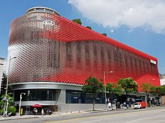

Kia central office at Gangnam District Seoul

However, during the Asian financial crisis, Kia declared bankruptcy in 1997; and in 1998 reached an agreement with Hyundai Motor Company to diversify by exchanging ownership between both companies. Hyundai Motor Company acquired 51% of the company, outbidding Ford Motor Company which had owned an interest in Kia Motors since 1986.^{[14]} After subsequent divestments,^{[15]}Hyundai Motor Company owns about one third of Kia Motor Corporation. While Hyundai Motor Company remains Kia's largest stakeholder, Kia Motor Company also retains ownership in some 22 different Hyundai Motor Company subsidiaries.^{[16]}

Since 2005, Kia has focused on the European market and has identified design as its "core future growth engine"—leading to the hiring of Peter Schreyer in 2006 as chief design officer^{[17]} and his subsequent creation of a new corporate grille known as the 'Tiger Nose'.^{[18][19]}
In October 2006, Kia Motors America broke ground for Kia Motors Manufacturing Georgia in West Point, Georgia, representing a $1 billion USD investment for the company.^{[20]} Kia Motors Manufacturing Georgia opened in February 2010, after Kia recorded its 15th consecutive year of increased U.S. market share.^{[21]}
In August 2014, the company received international attention when Pope Francis of the Catholic Church rode in one of their compact cars, the Kia Soul, during a five-day visit to South Korea.^{[22][23]}The Kia Soul drew bigger attention than two other vehicles used by the Pope, their Kia Carnival and Hyundai's Santa Fe, because it appeared in the high-profile welcoming ceremony of his arrival at the Seoul Airport on 14 August.^{[24][25]}
In 2016, Kia Motors model reliability was ranked first in the United States by J.D. Power and Associates, becoming the first non-luxury automaker since 1989 to top that list

AFFILIATIONS AND SUBSIDIARIES

Hyundai Motor Company

As of December 31, 2015, the Hyundai Motor Company owns a 33.88% stake in Kia Motors.
Likewise, as of December 31, 2015, Kia Motors is owner in 22 different Hyundai companies. Its ownership percentages range from 4.9% up to 45.37%.

Kia Motors Corporation

Kia Motors Corporation (KMC), founded in 1944, is South Korea's oldest manufacturer of motor vehicles and is now a subsidiary of the Hyundai-Kia Automotive Group. Over 1.5 million vehicles a year are produced in 13 manufacturing and assembly operations in eight countries. These are then sold and serviced through a network of distributors and dealers covering 172 countries. Kia today has 40,000 full-time employees worldwide and annual revenues of over US$14.6 billion. Kia Motors Corporation's brand slogan is "The Power to Surprise". From August 2009 until December 2012, the company has been led by Hyoung-Keun (Hank) Lee.

Kia Motors America

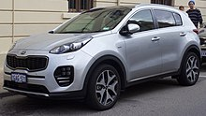
Kia Sportage

Kia Motors America (KMA) is the American sales, marketing, and distribution arm of Kia Motors Corporation based in Seoul, South Korea. KMA offers a complete line of vehicles through more than 755 dealers throughout the United States. For 2008, KMA recorded its 14th consecutive year of increased U.S. market share.
In November 2009, Kia started production at the first U.S. Kia Motors plant, Kia Motors Manufacturing Georgia, in West Point. As of December 2011, the facility was building the 2012 Kia Sorento crossover vehicle and the 2012 Kia Optima sedan. Headquartered in Irvine, California, Kia Motors America continues to top quality surveys and is recognized as one of the 100 Best Global Brands and 50 Best Global Green Brands by Interbrand.

Kia Motors Europe

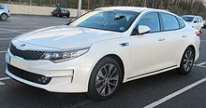
Kia Optima

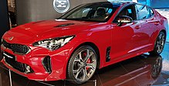
Kia Stinger
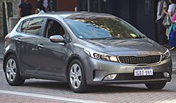
Kia Cerato

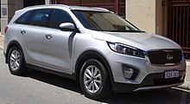

Kia Sorento

Kia Motors Europe (KME) is the European sales and marketing division of Kia Motors Corporation (KMC). It has been selling cars in Europe since the first half of 1991. In 2007, KME moved from its previous location at Hauptstrasse 185, Eschborn (near Frankfurt), to a new purpose-built facility adjacent to the Messe, in Frankfurt city centre.
From 1995 to 1999, Kia produced left- and right-hand drive versions of the first generation Sportage SUV at the Karmann factory in Osnabrück, Germany. From 1999 until production of the model ceased in 2003, all Sportage production reverted to South Korea.
When Kia launched in Europe during 1991, it initially sold only the Pride supermini - a rebadged version of the late 1980s Mazda 121. It initially proved popular with buyers, but sales fell towards the end of the decade, and the end of production was finally announced in May 2000, with its successor — the Rio — not going on sale for another year.
By the end of 1991, Kia had sold nearly 1,800 Prides in the United Kingdom. The first full year, 1992, saw that figure double, and, in 1993, it increased again to nearly 5,500 units.
The European range expanded in the spring of 1994 when Kia began importing the larger Mentor, a range of medium-sized hatchbacks and sedans which were marketed as inexpensive and well-equipped alternatives to the likes of the Ford Escort and the Vauxhall/Opel Astra. A facelift in 1999 saw the Mentor name retained for the saloon (sedan), but the hatchback was renamed Shuma. These models remained on sale until 2004,

when the newer Cerato was launched and gave Kia one of its first serious competitors against mainstream brands.
The Clarus saloon and Sedona MPV were also launched onto the UK market during 1999, helping Kia begin its rise in popularity.
The Sportage SUV range, first sold in 1995, has been popular across Europe, but, since 2002, Kia has gained more sales in this market thanks to the launch of the larger Sorento.
Despite Kia's range increasing from one car as late as 1993 to three cars by the end of 1995, British sales actually decreased in that period, from nearly 5,500 in 1993 to less than 4,000 the following year. In 1998, Kia's future in Britain was thrown into serious doubt when it sold less than 3,000 of its whole range – the worst in any full year on the British market.
Kia did not enter Europe's large family car market until the launch of its Clarus four-door sedan in 1999 - a year behind schedule due to the financial difficulties that Kia was facing before it was taken over by Hyundai. This car was similar in size to the Ford Mondeo and the Opel/Vauxhall Vectra, but, on its launch, was actually less expensive to buy than the smaller Focus and the Astra. It had a spacious interior, large boot, competitive asking price, and high equipment levels, but it had little more appeal to sway buyers away from established European brands like Ford, Vauxhall/Opel and Peugeot. Its successor, the Magentis, launched in 2001, was still nowhere near as popular as Kia might have hoped it would be, although with a sub-£14,000 asking price it offered the cheapest V6-engined car in the UK, by which time it was rare enough for a six-cylinder car to be priced at less than £20,000.
Kia entered the MPV market in 1999 with the Sedona. On its launch, it was the lowest-priced, full-size people carrier on sale in the United Kingdom.
With the range expanded by 1999, sales for that year reached almost 6,400 – more than double the previous year's total. That annual sales figure had almost been matched in 2000 by the end of May, reflecting Kia's growing popularity with British buyers. By 2009, Kia was firmly established as a popular brand in Britain, when sales broke the 50,000 barrier for the first time and the brand now had a share of more than 2% in the new car market. The Picanto was the most popular single model with nearly 17,000 sales.
In late 2006, Kia opened its first own plant in Europe at a cost of approximately EUR 1.7 billion in Žilina, Slovakia, in the village of Teplička nad Váhom, after construction between October 2004 and December 2005. It has since produced over 2.5 million units of the Kia Cee'd, Kia Sportage and Kia Venga, as well as seven types of engines. In 2016, 339,500 cars and 612,915 engines were manufactured. The area of the plant is 166 ha and Mobis Slovakia, the largest supplier, is situated right on the carmaker’s premises. As of December 31, 2016, 3,625 employees worked in the facility, while their average age was 35. The relatively low number of employees working in three shifts is related to a high degree of automation as well as high integration with Mobis Slovakia. In 2016, Kia Motors Slovakia recorded revenue of EUR 5.56 billion.
Although the European car market knows significant difficulties, Kia announced increased sales in 2013.

Kia Motors Mexico

The company has built a $1 billion manufacturing plant in the northern Mexican state of Nuevo León, which produces 300,000 cars a year. Details of the factory, built in the city of Pesquería, were revealed in a joint press conference given by Kia Motors CEO Hyoung-Keun Lee and the President of Mexico Enrique Peña Nieto in Mexico City on 28 August 2014. The plant was expected to be completed in the first half of 2016. This factory is involved in controversies because it was built on unevenly purchased land and the construction agreement was made with advantage conditions and out of the local dispositions to Kia.

Kia Motors India

The company is planning to enter the Indian market between 2019 and 2022^{[38]}. Kia plans to offer 3 vehicles, including a mid-size SUV and a compact sedan. The company is currently building a production facility on a Greenfield land in Anantpur district, Andhra Pradesh. The expected annual production capacity is 300,000 units.
Kia Motors appoints Kookhyun Shim as MD & CEO.In his new role, Shim will be responsible for leading the carmaker's expansion in the Indian market. Shim will play a leading role in ensuring KMI's projected timeline and schedule of operations is achieved. He will also oversee the construction of Kia Motor's first manufacturing facility in India, to help strengthen the company's position in the fifth largest global automotive market. Kia has committed investments to the tune of $1.1billion to develop operations in India.

Kia Defense

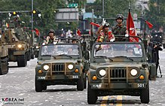
Kia KM420
Kia Motors has specialized in the production of military vehicles with variants and other transportation equipment and by supplying them as a sole maker of military vehicles designated by the South Korean Government since 1976, when Kia Heavy Industry Co. Ltd. (now known as Hyundai Wia) was established. Kia is currently designing a Kaiser Jeep M715-type vehicle named the KM450 for the South Korean Army on license from the U.S. Government. Kia is also the owner of the former ex-Asia Motors factory at Gwangju.

CONTROVERSIES

In late 2012, Kia Motors was forced to admit error in inflating its United States Environmental Protection Agency mileage claims and had to reduce its fuel economy claims in the U.S. by about 3 percent across the board and to offer compensation to previous vehicle buyers.^{[48]}

Nuevo León plant

Announcement of the Kia ensemble plant, Mexico City, 2014

From 2014 Kia Motors was involved in controversies in Mexico due to alleged irregularities in the construction of one of its plants in the municipality of Pesquería, Nuevo León. The construction of the plant was done in irregularly purchased landslide, and the agreement between Kia Motors Mexico and the Free and Sovereign State of Nuevo León, then headed by Rodrigo Medina de la Cruz, was signed with advantageous conditions to the South Korean company (like tax exemptions for 20 years when the standard are 5) and with tax incentives higher than those allowed by Mexican laws extended to the Mexican providers of Kia.^{[36]} A copy of the full agreement was published in Facebook by current Nuevo León governor, Jaime Rodríguez Calderón, as a part of a prosecution case to Medina^{[49]} and he declared that the signed agreement with his predecessor will be cancelled.^{[50]} A new agreement was reached with Rodriguez's administration on June, 2016.^{[51]}
Derived from the case, former governor Medina de la Cruz and other 30 officials of the former state administration were investigated by an anti-corruption prosecutor for alleged embezzlement, improper exercise of public functions and damage to Nuevo León State assets.^{[52][53]} Medina was placed in custody for this case on January 26, 2017, among other that he is involved.^{[52]}

DESIGN EMPHASIS

“ | In the past, the Kia cars were very neutral. When you saw one on the road, you didn't really know if it was Korean or Japanese…I think it's very important that you are able to recognize a Kia at first sight. | ”
— Peter Schreyer
Beginning in 2006 Kia identified design as its "core future growth engine" – leading to the 2006 hiring of Peter Schreyer and to the 2005 hiring Tom Kearns as Chief Design Officer. Schreyer had previously worked at Audi (designing the Audi TT) and Volkswagen and had won the Design Award of the Federal Republic of Germany. Kearns had previously worked at Cadillac as Chief Design Officer and was responsible for influencing Cadillac's direction of hard angles and sharp lines within their design.
Schreyer has since been central to a complete restyling of Kia's lineup, overseeing design activities at Kia's design centers in Frankfurt, Los Angeles, Tokyo, and the Namyang Design Center in South Korea.
With the Kee concept vehicle, shown at the Frankfurt Motor Show in 2007, Kia introduced a new corporate grille to create a recognizable 'face' for the brand. Known as the Tiger Nose, Schreyer indicated he wanted "a powerful visual signal, a seal, an identifier. The front of a car needs this recognition, this expression. A car needs a face and I think the new Kia face is strong and distinctive. Visibility is vital and that face should immediately allow you to identify a Kia even from a distance." Schreyer described how the Kia Tiger Nose came to be as he explained, "I was just working on the car and just thinking about different possibilities, and suddenly I found it."Commenting on the new signature grille in 2009: "From now on, we'll have it on all our cars".Kia has since featured the Tiger Nose on all of their vehicles, ranging from the compact Kia Soul, on to the edgy new design of the Kia Optima, and to the larger SUV, the Kia Sorento.
Kia cars have won the International Car of the Year award every year since 2013.

SENIOR MANAGEMENT TEAM
OF KIA MOTORS
Title  (Employment Status) | Name | Position
Vice Chairman  (Standing) | Hyoung -Keun Lee | CEO & Vice Chairman
President  (Standing) | Han-Woo Park | CEO & President
Executive Vice President (Standing) | Chun-Soo Han | CFO & Executive Vice President
Other Non-Standing Director  (Non-Standing) | Eui-Sun Chung | Vice Chairman of  Hyundai Motor Company
External Director  (Non-Standing) | Sang-Gu Nam | Member of Audit Committee,  Member of Ethics Committee,  Member of Board Nominating Committee
External Director  (Non-Standing) | Hyun-Kook Hong | Chair of Audit Committee,  Member of Ethics Committee
External Director  (Non-Standing) | Kwi-Nam Lee | Member of Ethics Committee,  Member of Board Nominating Committee
External Director  (Non-Standing) | Won-Joon Kim | Member of Ethics Committee,  Member of Board Nominating Committee
External Director  (Non-Standing) | Doo-Hee Lee | Member of Audit Committee,  Member of Ethics Committee

Mission

Building a new future and realizing humanity's dreams by thinking creatively and tackling challenges head on.
A business management philosophy outlines a company's reason for being while serving as a fundamental guideline that shapes the mindset and behavior of employees. The following three key phrases sum up Kia’s management philosophy: full accountability, realizing potential, and practicing humanity. These key values are encapsulated in a single mantra: ‘Building a new future and realizing humanity’s dreams by thinking creatively and tackling challenges head on.’
- Unlimited sense of responsibility
- Realization of possibilities
- Respect for mankind

Vision

Together for a better future
In 2011, Hyundai Motor Group established a new corporate vision: ‘Respecting people and practicing environmental management to maximize value creation and pursue balanced and shared growth with stakeholders. ’All subsidiaries will cooperate to fulfill this vision and turn Hyundai Motor Group into a top-tier global automotive group that provides customers with new value.
With the greater value we create by pooling our competencies, we will strengthen the soundness of partner firms and local communities while contributing to the sustainability of humankind.

Lifetime partner in automobiles and beyond
Under the Group-level corporate vision are detailed vision statements for each key business area. For the automobile business, the vision statement is ‘Providing a new space that makes life more convenient and enjoyable by realizing superlative mobility based on innovative people-oriented, eco-friendly technologies and comprehensive services.’
Kia Motors will offer products and services that befit this vision of turning cars from mere modes of transport into new lifestyle spaces.

Statement of Principles

We believe that each business transaction must be of the highest integrity and quality and must benefit both us and the customer.
We believe in providing the highest level of service possible with each transaction and recognize that service is the easiest way to differentiate ourselves from our competition.
We believe in the inherent worth of every human being. We treat each other, our customers, our vendors, and suppliers, and our competition with respect and caring.
We believe the secret to success is in satisfying customer's needs profitably. We always focus on our customer's needs and the most efficient way of meeting those needs. Profits are needed to sustain growth and assure our ability to meet customer's needs in the future.
We believe that competition is a good thing, not something to be avoided or eliminated. Competition is the fuel that drives us to be better. We recognize the need to change and grow in order to constantly find ways to satisfy customer's needs more efficiently.
We believe that individually and collectively, we must give back to the community some of the benefits we have received. We are not takers, but givers to the community in which we work and live.

CORE COMPETENCIES

The core values comprise the code of conduct for employees and the organization at large. They also represent the corporate culture we strive for and the promise we make to ourselves and stakeholders. We become one by sharing the same values and applying them consistently in our decision making processes. Kia Motors will tackle challenges head on through mutual cooperation and respect while fulfilling our pledges and embracing talent and diversity to build a distinct corporate culture.


We promote a customer-driven corporate culture by providing the best quality and impeccable service with all values centered on our customers.
- 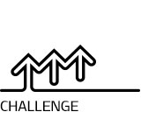
We refuse to be complacent, embrace every opportunity for greater challenge, and are confident in achieving our goals with unwavering passion and ingenious thinking.
- 
We create synergy through a sense of “togetherness” that is fostered by mutual communication and cooperation within the company and with our business partners.
- 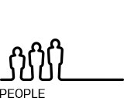
We believe the future of our organization lies in the hearts and capabilities of individual members, and will help them develop their potential by creating a corporate culture that respects talent.
- 
We respect the diversity of cultures and customs, aspire to be the world’s best at what we do, and strive to become a respected global corporate citizen.

BRAND SLOGAN
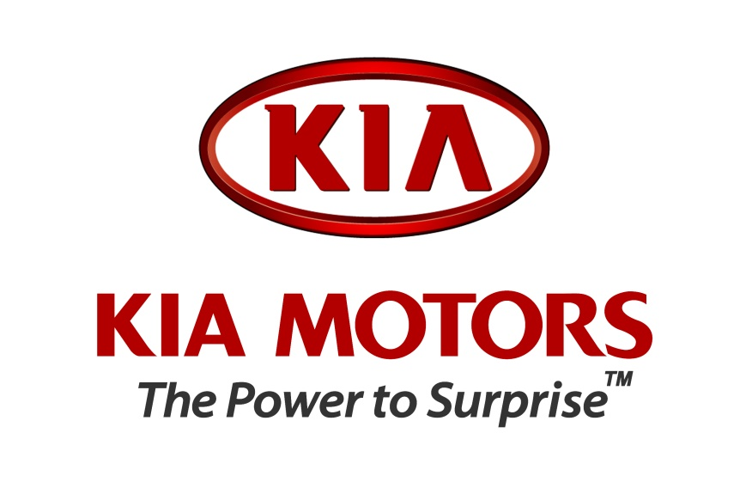

“The Power to Surprise”
Starting from 2005, the company has been engaged in enhancing the brand power and improvement of the company reputation through the brand slogan of “The Power to Surprise,” with continued efforts for innovation in product development, communication, sales, services, and other customer-related activities.
KIA Motors has seen a steady increase in its brand value since its entry into the top 100 global brands list in 2012. As a result, the value of brand this year marked US$ 6.7 billion, up by 6% from the previous year.
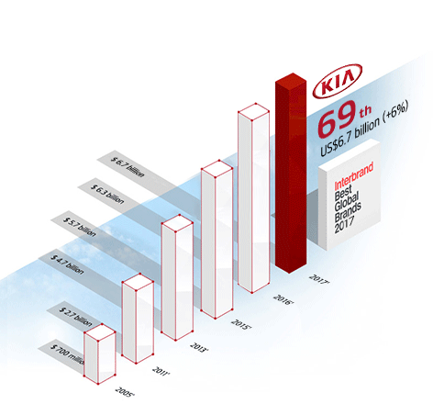

Passenger cars

- Cadenza/K7
- Cee'd/Cee'd SW/
- Forte/Cerato/K3
- Forte Koup
- K9/K900/Quoris
- Optima/Magentis/K5
- Picanto/Morning
- Ray
- Rio/Rio5/Pride
- Soul
- Stinger
- Stonic

SUVs & VANS
- Carens/Rondo
- Carnival/Sedona
- Mohave/Borrego
- Sorento
- Sportage
- Pregio

Commercial vehicles
- AM928 – KMC only
- Granbird – KMC only
- Bongo, also sold as K2700/Strong/3000S/2500TCI
- K4000s – KMC only

Hybrid electric vehicles
Kia unveiled hybrid electric concept cars at the 2008 Paris Motor Show:
- Kia cee'd Hybrid
- Kia Niro Hybrid Utility Vehicle
- Kia RayPlug-in hybrid
- Kia Soul EV
- Kia Optima Hybrid

SWOT ANALYSIS

Strengths
1. One of South Korea’s largest Automobile producer
2. Among the top 5 Largest Automobile Manufacturer based on its sales
3. It has strong presence due its sponsorship to events like the Formula 1, Euro Cup, Australian Open, FIFA World Cup, X-Games in US
4. Around 42,000 employees
5. Good product portfolio and strong brand presence
6. Has sales of nearly 1.5 million cars per year

Weaknesses

1.Past recall of critical components like the Braking System was a concern
2. Has not leveraged its presence & recognition globally even as it has created so many sponsorships
3.Has not expanded aggressively in terms of the geographic reach

Opportunities
1.Venture into emerging economies which a huge markets
2. It can also enter various where Hyundai is present to fill up gaps in the product offering which Hyundai cannot, e.g. in India Hyundai has failed to attract large numbers for its luxury SUV Santa Fe which may have worked better through the Brand Name of Kia
3.Enter the Defence market in the newly liberalized countries of the Jasmine Revolution since it already is existing in the Defence sector
4. Their all electric vehicles like the Venga & Pop City can open new avenues of business for Kia

Threats
1.The Japanese players have made their presence in most of the markets around the world & secured steady market shares
2. The competitors have better design & technology thus having better differentiation

Competitors
1.Toyota
2. Honda
3. Nissan Motors

FINANCIAL STATEMENTS OF KIA MOTORS

Income Statement

 | 2016 | 2015
Revenue | $52,712,906 | $49,521,447
Gross Profit | $10,431,316 | $9,867,678
Operating Profit | $2,461,480 | $2,354,273
Recurring Profit | $3,442,034 | $3,100,266
Net Profit | $2,754,640 | $2,630,600

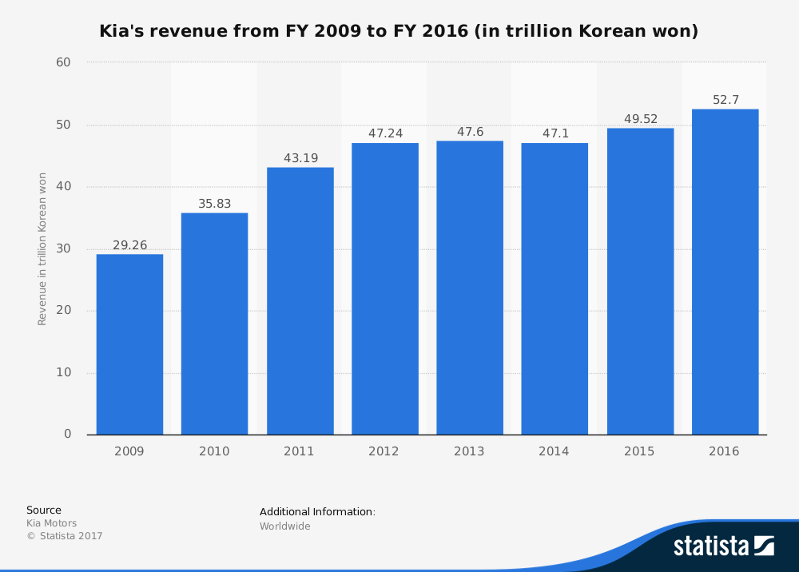
INNOVATION IN KIA MOTORS

KIA Design
Kia’s Design is not just about shapes, lines or surfaces it is a sharing of unexpected new pleasant experiences with the world’s customers.
We at Kia have understood the heartbeat of our customers which is why all our automobile designs are incredibly exciting, sporty, sassy, stunning and vivacious; the list of adjectives is endless. Design plays an imperative role in communicating with customers. Kia will consistently create a different beat in the automotive world through our designs.

KIA TECHNOLOGY

Power and innovation
Models created in a digital world are put through a simulation analysis test and installation evaluation through auto simulation and a 3-D digital design process to review possible problems in advance. This process greatly optimizes engineering design and minimizes development times.

Intelligent infotainment systems to fulfill every desire
Vehicles of the future will feature diverse electronic systems befitting the information age and offer greater safety features than ever before. Smart cars with infotainment systems will also offer the latest electronic technologies and equipment so that driving will be more comfortable and enjoyable as well as safer.

Safety always comes first
Advanced technology to protect the driver and passengers on all roads and under all circumstances. Kia Motors R&D Center is a world leader in developing tests and cutting-edge technology such as ABS, EBD and VDC that safely protect people from any situation that may occur on the road.

ECODYNAMICS
The ultimate goal of sustainable mobility is zero emissions!
Kia Motors takes the first step toward this dream with "EcoDynamics"

Hybrid electric Vehicle (HEV)
Various hybrid models are already out in the market. HEVs are catching on more quickly than other green vehicles given that they can make use of existing infrastructure. Competitiveness in the HEV market hinges on securing technologically-advanced and cost-effective electric motors, inverters, batteries and other electric power components, and Kia Motors is making notable progress on these fronts.Since 2005, Kia Motors, in collaboration with the Ministry of Environment, has been running a pilot fleet of Pride (Rio) Hybrid vehicles. With proprietary technologies secured through the project, Kia Motors released the Forte LPi Hybrid, the world’s first HEV to be equipped with a lithium-ion polymer battery. Its CO2 emissions level (99 g/km) is one of the lowest among Korean cars.

Electric Vehicle (EV)
EVs are powered solely by the electric motor and use the electric energy stored in the high-voltage battery for starts and acceleration. The battery can be fully charged in six hours using a household charging system. At high-speed charging stations, it only takes 25 minutes.As they run only on electric power, EVs do not emit any CO2 and are more economical than gasoline-powered vehicles in terms of fuel costs. However, given that most electric energy is currently generated through fossil fuel-based systems, EVs are responsible for indirect CO2 emissions. Moreover, EV-related infrastructure is still lacking.

Fuel Cell Electric Vehicle (FCEV)
No matter how advanced our technologies become, cars that run on fossil fuels are bound to emit exhaust. Accordingly, a truly green alternative is a vehicle that runs on something other than fossil fuels. Hydrogen FCEVs run on electricity generated by the chemical reaction between hydrogen and oxygen induced by the fuel cells. Since the only by product is water, FCEVs can tackle the twin issues of environmental degradation and energy depletion. The efficiency of the FCEV engine is also twice that of existing internal combustion engines. For the commercialization of hydrogen FCEVs, however, we first need an infrastructure of hydrogen fueling stations and a more energy-efficient manufacturing process.

SAFETY

Vehicle body structure made of ultra-high tensile steel
Body of a vehicle usually refers to the frame on the surface. It takes up about 30 percent of the vehicle's total weight and plays a pivotal role in the vehicle's crash safety and styling. A vehicle body made of ultra-high tensile steel via hot stamping method allows the car to be lighter while increasing their rigidity. The result: better fuel efficiency and crash safety.

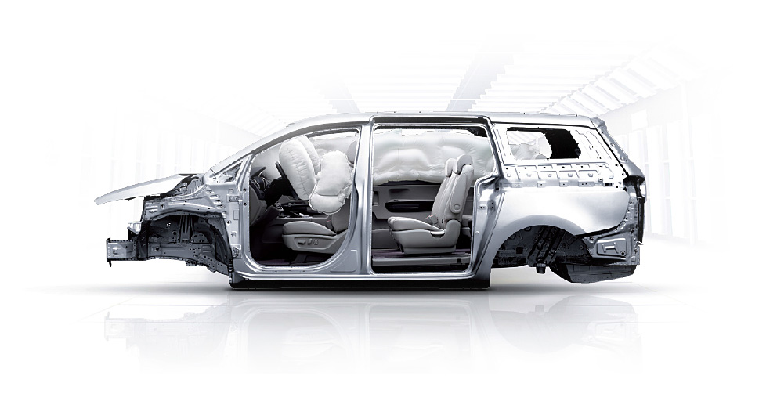

Airbag

In a Kia car, your safety is ensured as it has a full set of airbags, including driver/passenger seat airbag, driver knee airbag, curtain airbag and front/rear side airbag, whoever you drive with and however you might be impacted.

Seat Belt Pre-tensioner

A seat belt pre-tensioner is a device that is used to hold a passenger firmly in their seat just before and at the start of a collision and then allow that passenger to come into contact with the inflated in a controlled way.

Bumper Systems for Pedestrians

Lower legform / lower stiffener

Upon impact between a pedestrian and a car, the lower legform or lower stiffener can minimize the bending of his/her knee and make him/her fall onto the car to reduce the possibility for him/her to go under the car and end up in a more critical state.

Technologies to Avoid Impact
The focus of safety has been how much the occupants on board or pedestrians can be protected. Now a new question is emerging regarding car safety: how well an impact can be avoided.

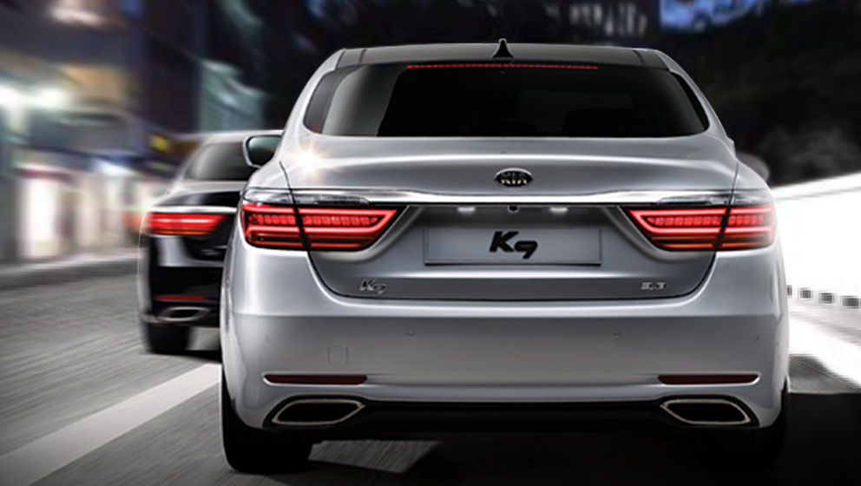

Autonomous Emergency Braking (AEB)

The ASCC radar sensor and the LDWS camera automatically apply the brakes to a vehicle upon detection of an unexpected forward collision due to the sudden braking of the preceding vehicle or careless driving.
(AEB : Autonomous Emergency Braking)

ENGINES THAT CAN PROVIDE THE POWER TO RUN IN ANY CONDITION

We put our engines through rigorous testing in the highest, hottest and coldest places that a car can possibly be before we use them in our cars.

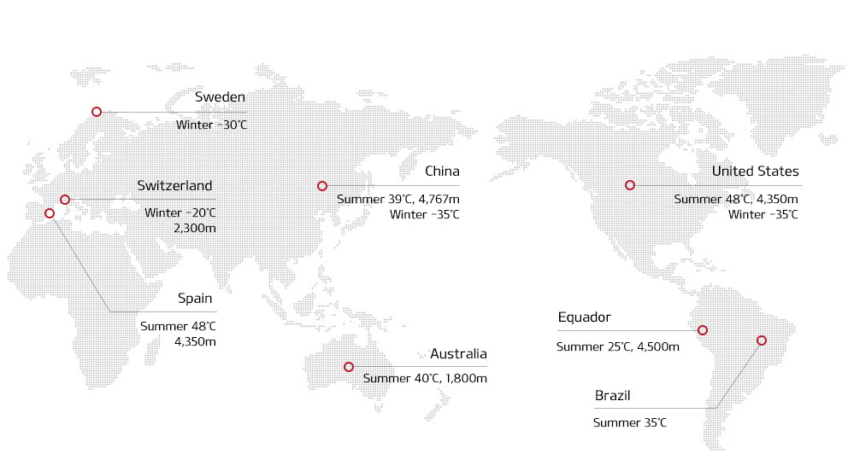

REAR-WHEEL DRIVE PLATFORM

Rear wheel drive places the engine in the front of the vehicle and the driven wheels are located at the rear. This results in balanced weight distribution for higher steering stability. Rear wheel drive also enables greater driving performance since the front wheels are responsible for steering and the rear wheels for driving. In addition, it allows for greater grip on the rear wheel for better acceleration. Wheelbase is larger on the rear wheel drive platform, resulting in larger cabin room.

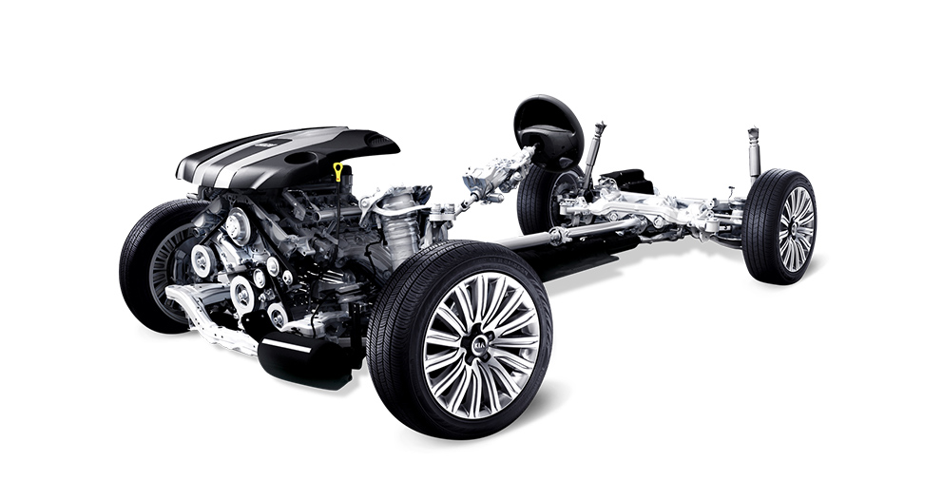

DYNAMIC PERFORMANCE INNOVATION

A wide range of controls and driving assists on a Kia car will get you unparalleled driving experiences.

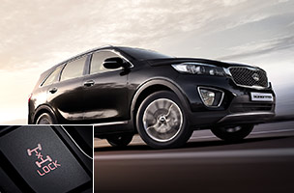
Electronic 4WD

A system that changes the distribution of driving force between front and rear wheels to enhance driving performance

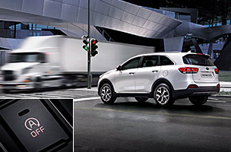
Advanced Idle Stop & Go System

A system that stops the engine when the brake pedal is pressed to prevent idling and ultimately improve actual fuel efficiency

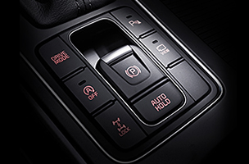
Electronic Parking Brake & Auto Hold
With this system, the parking brake is engaged and disengaged at the push of a button. The brake gets automatically disengaged when you start the car.

Durability test

Seven ways to ruin your car
We ruin our cars in various ways, identify causes and find solutions to them to make our cars endure over a long time without fault.

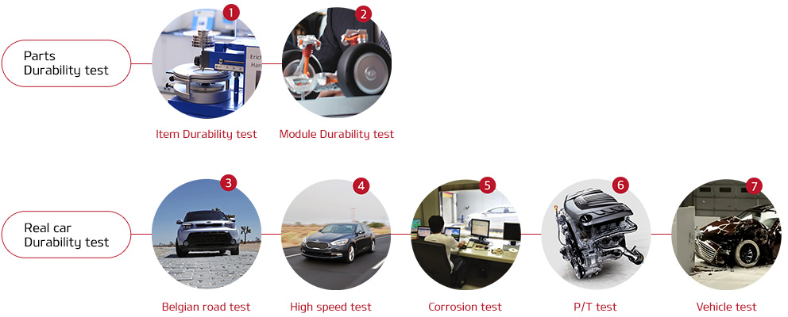

FUTURE PLANS OF KIA MOTORS

The Kia brand is very much on the rise, and the Koreans are now looking ahead to the next chapter in their success story.The last few years have been devoted to redesigns and the release of new models followed by short periods of inactivity.Kia has now built their line-up to the point where they want it to be, which means it’s time to start thinking about new models.
The likelihood is that Kia will start delivering 2 new models per year.With these new releases in 2019, Kia will be looking to continue delivering a better quality of ride and handling, whilst also focusing on creating better powertrains and updated technology.
Brand perception is also on their mind, and the release of the new K900 flagship sedan should certainly help in that department.
Let’s take a closer look at what Kia Motors have in store for us in 2019.

New 2019 Kia models
K900: The K900 has now been on the market for 5 years, and the flagship sedan is ready for its next big makeover. The new look will include changes to both the exterior and cabin of the vehicle. New powertrain technology, including the AWD system, is just one of the changes we will see.
Soul crossover: The Soul crossover is perhaps Kia’s biggest success story, and the iconic boxy model will get a full makeover for the 2019 model year. The US premiere of this model is expected sometime next year. The boxy look of the car is here to stay!
Forte: There’s also a new Forte 4-door in the works, with the all-new model expected to hit the U.S. market next year. The new model will have a full redesign inside and out, and will also feature improved powertrain technology. No word yet on what to expect from the 2019 Forte 5-door hatchback.
Cee’d: This model is one that is only available in Europe. The latest model should get its premiere at the upcoming Geneva Motor Show, and the belief here is that the Cee’d family will include a 5-door hatchback, a wagon, and a crossover version in the 2019 model year. Rumor has it that the 3-door model is being discontinued, but no official word yet.
Niro EV: The Niro EV, an all-electric model, will hit showrooms next year, and will come with a 200-hp electric motor and a range in excess of 200 miles.

KIA MOTORS INDIA

Plant Location
Anantapur District, Andra Pradesh
Production Capacity
300,000 units annually
Site Area
23 million square feet (2.16 Km² or 536 acres)

These are truly exciting times for all of us at Kia Motors, as we eagerly await our very first interaction with Indian customers in 2019 when our US$1.1 billion manufacturing facility in Andhra Pradesh begins mass production.
With annual production capacity of 300,000 units, the plant will ensure timely and smooth provision of Kia vehicles that boast world class levels of quality and design.
While the model names have yet to be announced, Kia plans to produce a strategic compact sedan and compact SUV at the plant, and we are confident that these additions to Kia's growing global product line-up will be embraced by consumers throughout India. We at Kia Motors are eagerly counting down the days until we meet our valued customers in India.
Please stay tuned for more updates during the course of the exciting journey ahead, as we open a new chapter for the Kia brand in India.

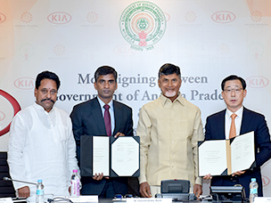

Kia Motors has signed an MOU with the State Government of Andhra Pradesh, India to build a new manufacturing facility in Anantapur District.

