Kia Rio 2013 D 1.1 – Fuses and Relays
Component Location
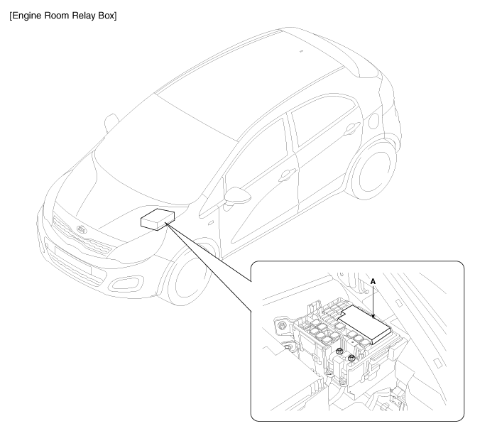
1. PCB fuse & relay box (Head lamp low/ hi, Fuel pump #1, Fuel heater, HAC, Engine control, ESS, Front wiper, Rain sensor, Blower, Cooling fan low/ hi, Horn, Buglar alarm horn, Start relay)

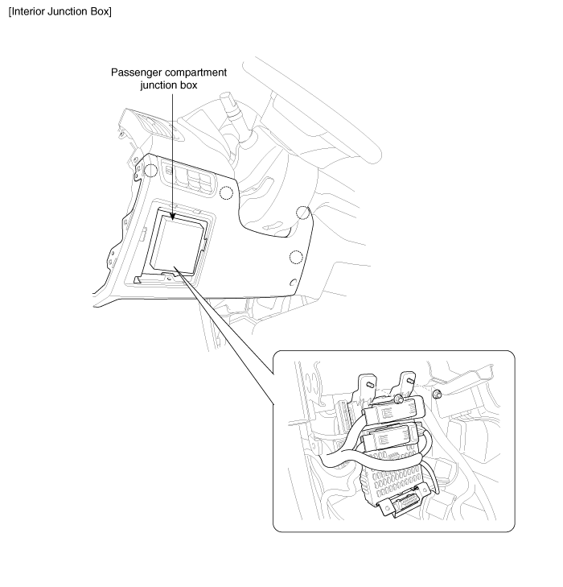
Components
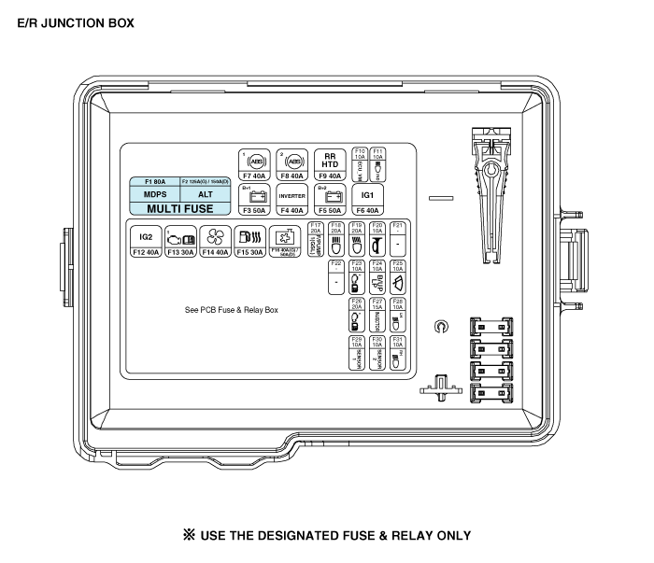
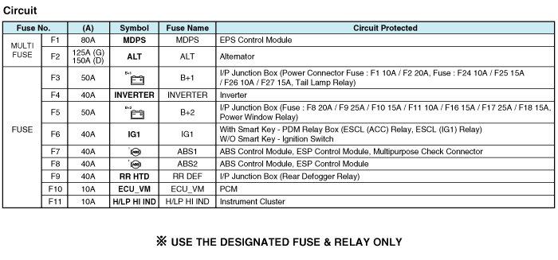
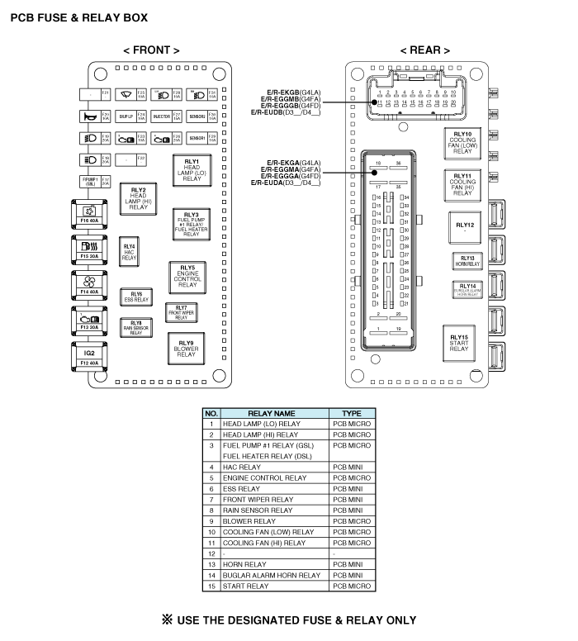
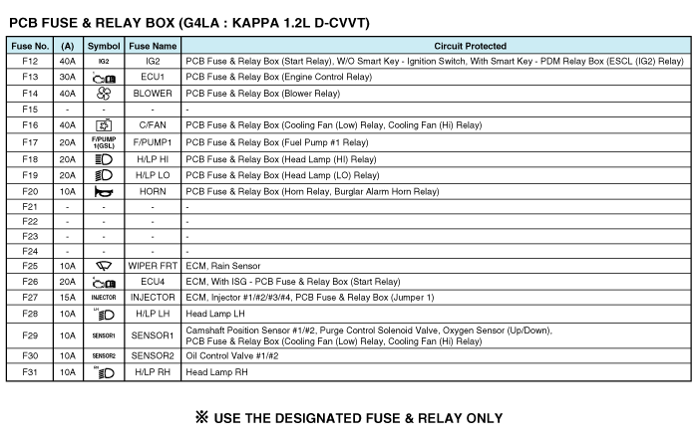
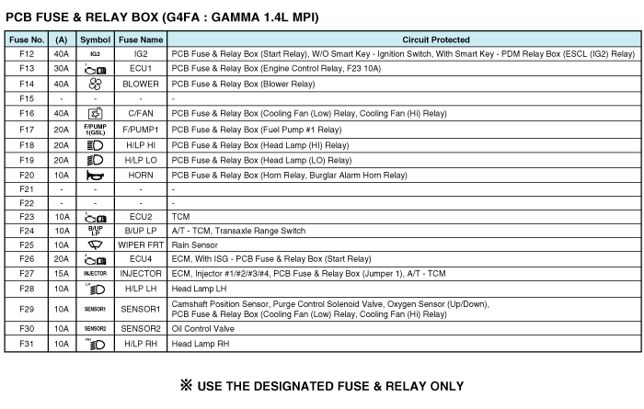
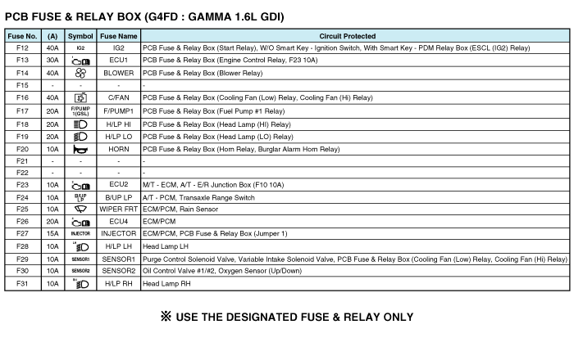
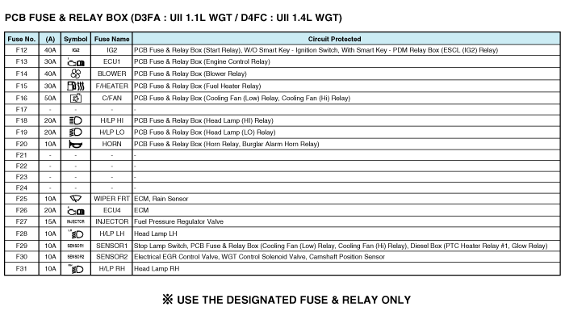
Inspection
Replacement of EMS box
1. | Disconnect the negative (-) battery terminal.

2. | Push hooks in the engine room relay box out to the arrow direction and put up the EMS box assembly (A).  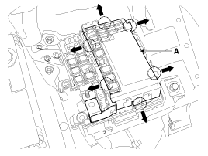

3. | Disconnect the connector (A) and remove the EMS box assembly (B).  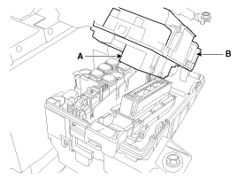
Fuse Inspection
1. | Be sure there is no play in the fuse holders, and that the fuses are held securely.

2. | Are the fuse capacities for each circuit correct?

3. | Are there any blown fuses?  If a fuse is to be replaced, be sure to use a new fuse of the same capacity. Always determine why the fuse blew first and completely eliminate the problem before installing a new fuse.
Multi Fuse
Multi Fuse is for optimizing the engine room package.
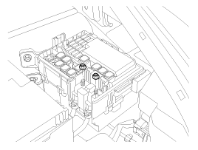
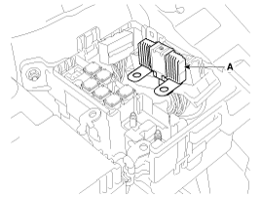

- | Multi fuse (A) is needed to replace entirely when there is damage to only one fuse.

- | When replace the multi fuse, refer to the "Engine compartment - component location" diagram exactly.

- | Use the multi fuse capacities for each circuit correctly.

Components
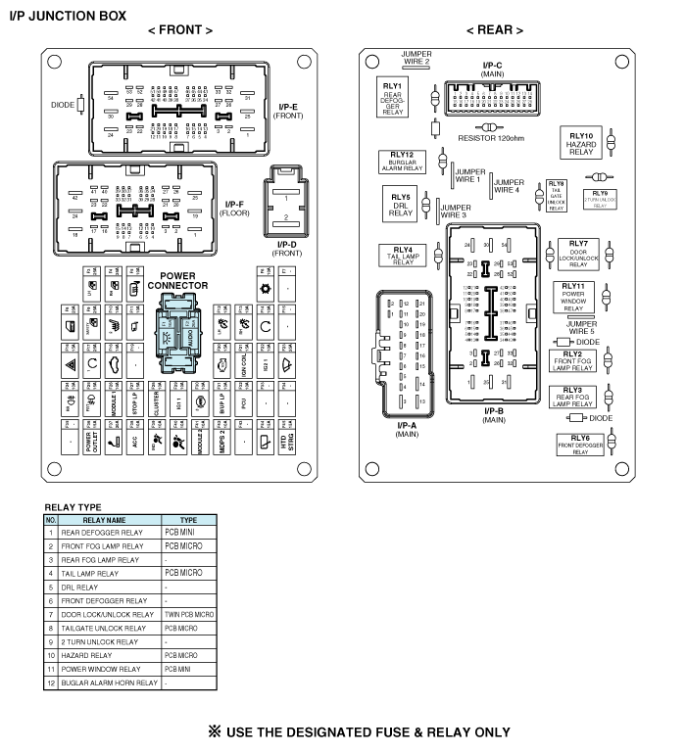
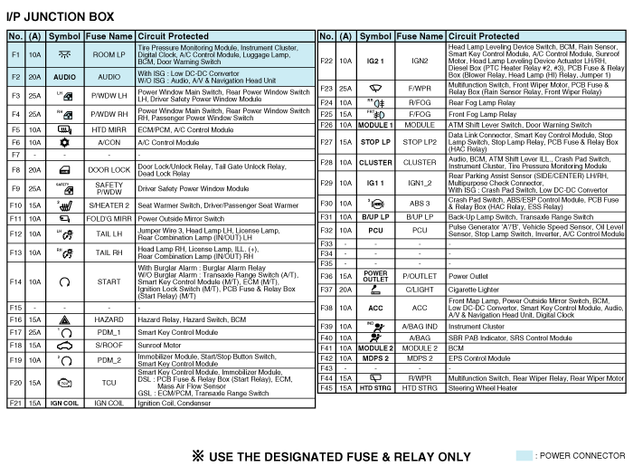
Fuse Inspection

1. | Be sure there is no play in the fuse holders, and that the fuses are held securely.

2. | Are the fuse capacities for each circuit correct?

3. | Are there any blown fuses?  If a fuse is to be replaced, be sure to use a new fuse of the same capacity. Always determine why the fuse blew first and completely eliminate the problem before installing a new fuse.

Removal
Passenger Compartment Junction Box
1. | Disconnect the negative(-) battery terminal.

2. | Remove the crash pad lower panel.  (Refer to the BD group - "Crash pad")

3. | Disconnect the connectors from the fuse side of the interior junction box.

4. | Remove the interior junction box(A) after loosening the mounting nuts (2EA).  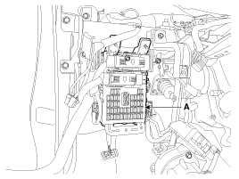

5. | Disconnect the connectors from the back side of the smart junction box.

Installation

1. | Install the interior junction box.

2. | Install the crash pad lower panel.

3. | Check that all system operates normally.

